ANALYSIS INSIGHTS

Query 1: Total number of players

Insight: this query gives us the total number of players participating in the Euro 2024 football.

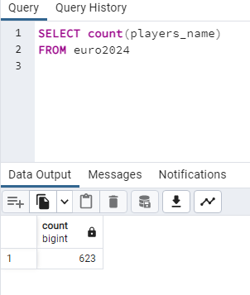

Query 2: Players from Germany

Insight: this query shows us the total number of players from Germany.

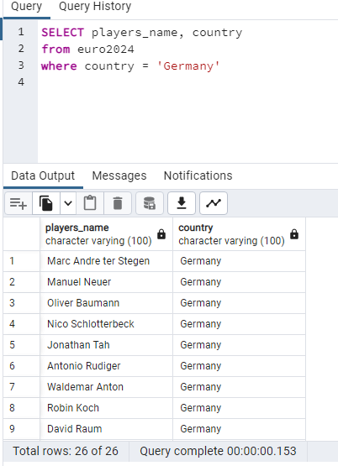

Query 3: Goals scored by players

Insight: this query shows us the total number of goals scored by individual players.

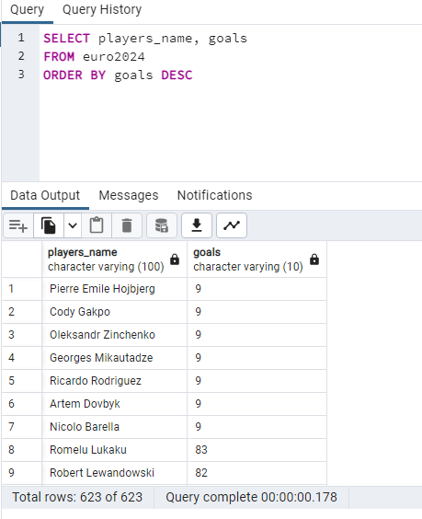

Query 4: Players who have scored no goals

Insight: This insights shows the bottom 30 players with 0 goal record.

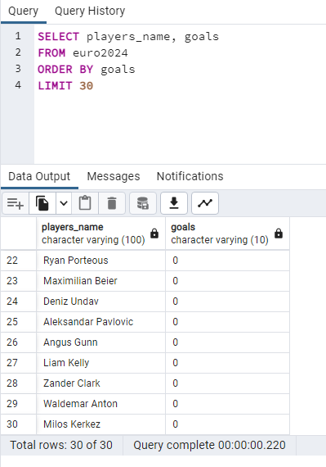

Query 5: Age range of players

Insights: This insight shows us the youngest players that falls between the age range of 15-24 years.

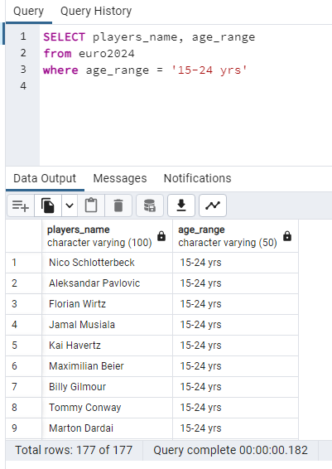

Query 6: Players foot preference

Insight: This shows us all the players that prefer using both foot for playing.

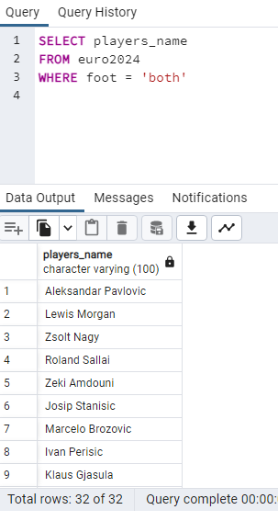

Query 7: Count of player by Country

Insights: This query shows us the total number of players participating from different countries.

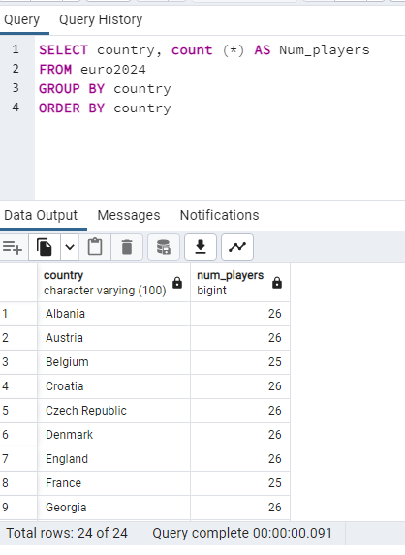

Query 8: Aggregate Function

Insight: This query shows us the total number of payers with Caps that’s equal to 5 or Goals that’s equal to 10.

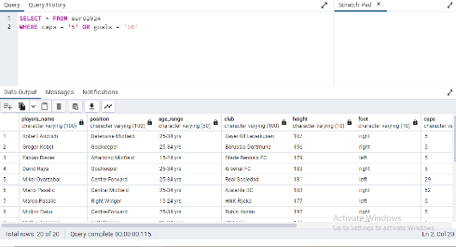

Query 9: Players name that begins with J

Insight: This shows us all the players name that begins with J.

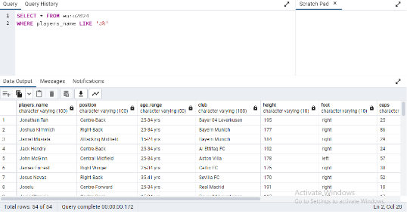

Query 10: Players that are not in their prime

Insight: This insight shows us the list players that are no longer in their prime age. They fall within the age range of 35-41 years.

